WELCOME TO

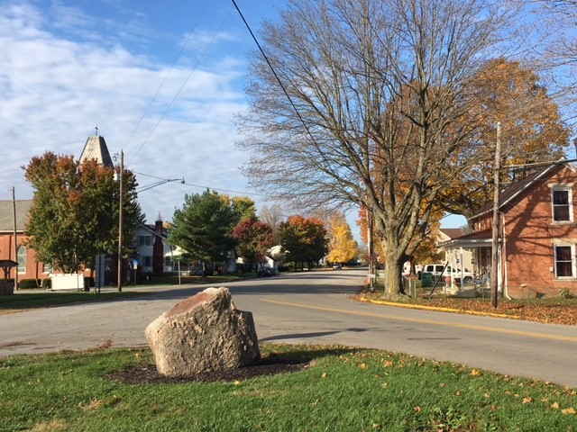LOCKBOURNE

*Commerce Street*



Resident Information Packet

Table of Contents

Welcome from the Mayor 2

Welcome from the Safety Committee 3

Contact Information 4

Elected Officials & Public Meetings 5

Village Communications 6

Village Services 7

Trash Collection & Recycling Program 7

Street Sweeping 8

Water & Sewer 8

Utility Services 9

Lockbourne School District 10

Code Enforcement 11

Income Tax 13

Parks and Recreation 14

2020 Community Calendar 15

2020 Special Events 16

Lockbourne’s Organizations 17

History of Lockbourne 18

Lockbourne Businesses and Churches 19

Lockbourne Businesses 19

Lockbourne Churches 20

Local Attractions 21

Parks & Recreation 21

Arts & Theater 21

Sports 21

Restaurants 22

Pizza 22

Learning 22

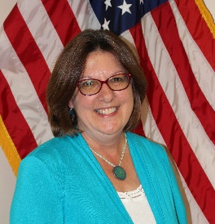**Welcome from the Mayor**

*Welcome to Lockbourne! Our home, our community, our story!*

*We are glad that you have chosen Lockbourne as your home. You will quickly find that Lockbourne is a tight-knit community. It is a place where residents still sit on their porches, know their neighbors and watch out for each other.*

*We want to help make your move to Lockbourne an easy one. Inside this packet, you will find information to help you relocate to the Village of Lockbourne.*

*The staff and council work hard to be accessible and responsive to our residents. If you have any questions or concerns, please feel free to contact me at (614) 491-3161 or at* [*christie.ward@lockbourneohio.us*](mailto:christie.ward@lockbourneohio.us)*. You can also contact members of Village Council via the contact links provided at* [*http://www.lockbourneohio.us/about/contact-us*](http://www.lockbourneohio.us/about/contact-us)*.*

*To stay connected to what is going on in town, sign up for the Lockbourne Village View Newsletter at* [*admin.assistant@lockbourneohio.us*](mailto:admin.assistant@lockbourneohio.us)*, to receive our newsletter via email. Also, follow us on Facebook at* [*www.facebook.com/Lockbourne*](http://www.facebook.com/Lockbourne) *to get the most current information.*

*Again, welcome to Lockbourne. See you around town!*

*Christie Ward*

*Mayor*

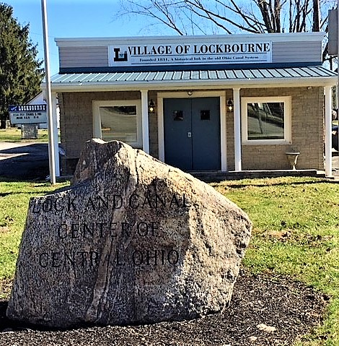

*Municipal Building*

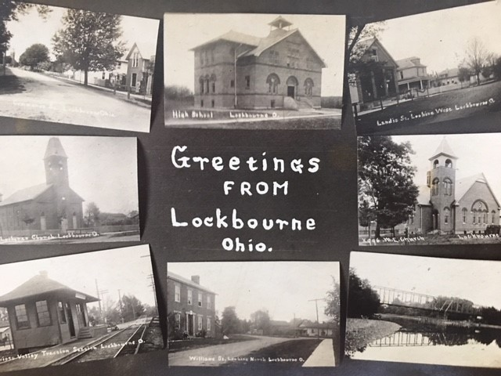

*Postcard from Early Days*

# Welcome from the Safety Committee

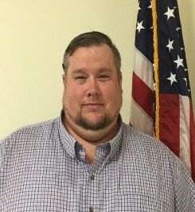

*On behalf of the Village of Lockbourne Safety Committee, I would like to welcome you to town. The Safety Committee is dedicated to keeping our community safe for you and your family.*

*We work closely with the Franklin County Sheriff’s Office, who provides patrol for the Village. If you have a problem, concern or would like to report a* ***non-emergency*** *situation, please contact the Sheriff’s Office at* ***(614) 525-3333****. We encourage you and your family to enter the police non-emergency number into your cell phone*.

*Your safety is our first priority. . . .please help us by being alert, security conscious and involved. Below are some helpful tips to keep in mind to ensure everyone’s safety.*

* *ATVs, motorized bikes and 4 wheelers are NOT permitted on the streets or in any of the Village parks and trails.*
* *Coyotes have been seen in the area and occasionally in the Village, so watch your pets if they are out at night.*
* *We have received several complaints of speeding throughout the Village. The Safety Committee is working with the Sheriff’s Office, as well as working on a street plan, to help reduce speed. When driving through town, please drive the speed limit, which is* ***25 mph****.*

*The Safety Committee meets the fourth Monday of the month at 6:30 pm at the Municipal Building, 85 Commerce Street, Lockbourne, OH 43137. If you are interested in joining the Safety Committee, please contact the Village office at (614) 491-3161.*

**Sheriff’s Office**

The Village is patrolled by the Franklin County Sheriff. For any emergency calls, please dial 911. For non-emergency calls, please dial (614) 525-3333. Follow the Franklin County Sheriff on Facebook at [www.facebook.com/OHFCSO](http://www.facebook.com/OHFCSO).

**Fire Department**

Hamilton Township provides services for fire and EMT. Fire stations are located at 6410 Lockbourne Road and 1460 Obetz Road, Columbus OH 43207. For any emergency calls, please dial 911. For non-emergency calls, please dial (614) 491-1030 for the station located on Obetz Road and (614) 491-1050 for the station located on Lockbourne Road.

# Contact Information

**The Village of Lockbourne**

85 Commerce Street

Lockbourne, Ohio 43137

Phone: (614) 491-3161

Fax: (614) 491-8070

**Emergency Phone Numbers**

Emergency: 911

Franklin County Sheriff: (614) 525-3333

Hamilton Township Fire Department (614) 491-1050

Poison Control (800) 222-1222

**Important Phone Numbers**

Animal Control (614) 525-3400

AT&T (800) 784-0574

Capital Area Humane Society (614) 777-7387

Franklin County Public Health (614) 525-3160

Franklin County Sanitary Engineers (614) 525-3940

South Central Power (800) 282-5064

Local Waste (614) 409-9375

**Important Note Regarding 911:**

Emergencies are situations that require immediate response by police, fire, or medical personnel to preserve life or property. Intentional misuse of the 911 system is violation of law and may delay response to someone else in need of emergency assistance.

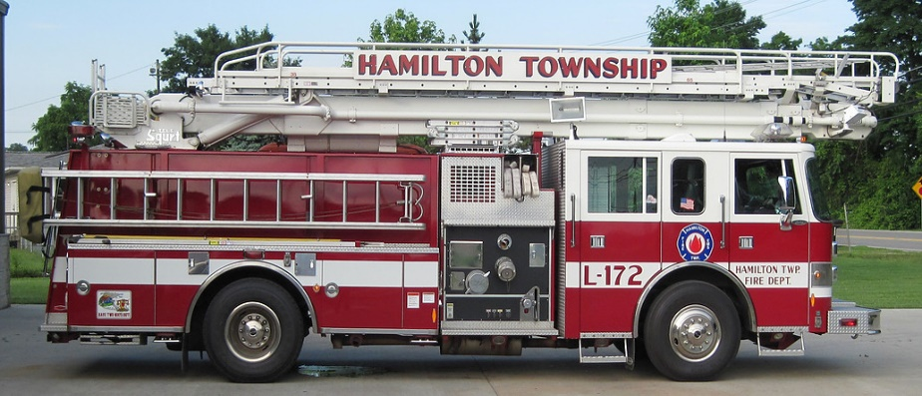

# Elected Officials & Public Meetings

**Mayor**

Christie Ward

**President Pro Tempore**

Susan Grandstaff

**Members of Village Council**

Bobbi Crouse

Tony Grandstaff

Tammy Langley

Mary Petty

James Tiller

**Lockbourne Village Meetings**

All Village Meetings are held at the Municipal Building, 85 Commerce Street

Village Council Meetings: 2nd and 4th Monday @ 7:00 pm

Committee Meetings:

Economic Development Committee: 2nd Monday @ 6:00 pm

Planning Commission: 1st Thursday @ 6:30 pm

Safety Committee: 4th Monday @ 6:30 pm

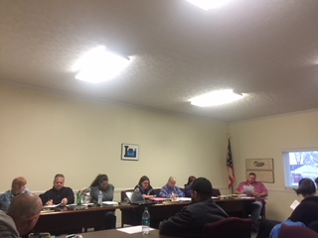

*Council Meeting*

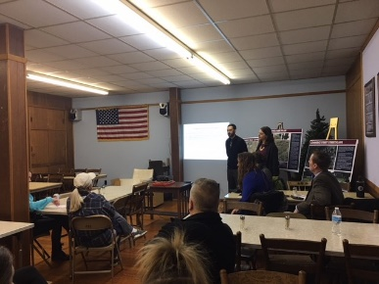

*Town Hall Meeting*

*Council Meeting*

# Village Communications

**Village Website**

<http://www.lockbourneohio.us/>

The Village Website provides residents with updates on important community events and announcements. Our website has a new look, where you can download permits and forms and view meeting agendas, meeting minutes, etc. We are working on getting our ordinances on the site as well!

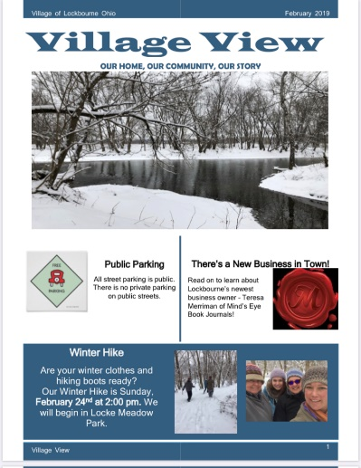**Village Newsletter**

The Village View is a monthly newsletter delivered to residents and friends of Lockbourne. Extra copies can be found in the post office. The newsletter focuses on news and events coming up in the next month. Sign up to receive the newsletter via email by contacting the office at admin.assistant@lockbourneohio.us. If you do not have an email address, we will continue to deliver a newsletter to your door.

**Social Media**

**Friend us on Facebook!**

Get current news and information about the Village on our Facebook page.

<https://www.facebook.com/Lockbourne/>.



**Newspapers**

General circulation papers that are delivered in Lockbourne.



# Village Services

## Trash Collection & Recycling Program

Trash, curbside recycling and curbside yard waste collection services are provided by Local Waste and is paid for by the Village. Please contact the municipal building to get on the trash pickup list. **Council has agreed to continue to pay the residents’ trash through the end of 2021.**

Trash collection and curbside recycling will be picked up each **Thursday**, except when a National Holiday falls on Monday, Tuesday, Wednesday, or Thursday. Then pick up will be on Friday.

Each household is provided one trash bin and one recycling bin at no cost. If any resident wants an additional trash container, contact Local Waste at (614) 409-9375. There will be a $36.00 annual fee that the resident will be required to pay. The Village will NOT pay for additional trash containers.

Refuse containers must be returned to the building line of each residence within twenty four (24) hours after trash collection. (*Ordinance 13-75)*

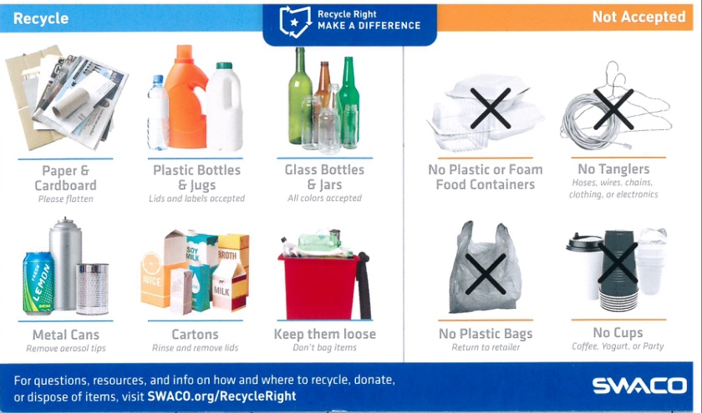**Do NOT bundle or place recycling materials in plastic bags, place loosely in bins.**

**Yard Waste Pickup**

Yard waste will be picked up with the trash collection. Tree limbs and shrubbery must be cut and bundled with biodegradable twine or string. Grass, leaves and plant materials should be placed in biodegradable paper or other paper bags.

**Hazardous Household Materials**

For disposal of paint, and other hazardous household materials not listed above, please contact SWACO at (614) 871-5100 for a schedule of drop-off locations. SWACO will not accept: appliances, tires, trash, propane tanks (over 20 lbs.) asbestos, needles, medical waste, used oil, car batteries, household cleaners and latex paint. Latex paint, when dried, is not considered hazardous and can be disposed in your bagged and tied trash. If the latex paint has not dried, stabilize it with cat litter or sawdust before disposing of in the trash. Visit [www.swaco.org](http://www.swaco.org) for more information.

If there are any issues with trash and recycling collection, call the Village office at (614) 491-3161.

## Street Sweeping

Weather permitting, street sweeping is tentatively scheduled for early Spring and late Fall. The exact dates will be posted on the Lockbourne Facebook page and on our website. No parking signs will also be posted. Your compliance with no street parking on the day(s) for street sweeping is critical to enable the Village to remove debris from the gutters and streets, which, if allowed to accumulate, contributes to localized flooding. Only streets with curbs will be cleaned.

## Water & Sewer

Water and sewer services are provided by the City of Columbus. Water and sewer maintenance and billing are provided by Franklin County. Bills are sent to residents on a quarterly basis; however, you may elect to pay on a monthly basis.

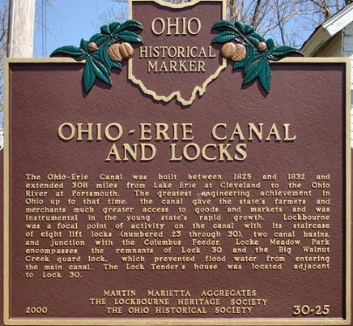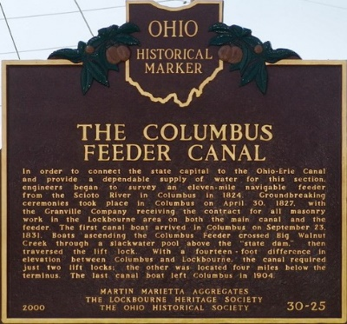Please contact the Franklin County Sanitary Engineers at (614) 525-3940 with any questions.

## Utility Services

**Electric**

South Central Power (740) 653-4422

**Heating Options** (Propane)

AmeriGas (800) 722-5757

Buckeye Propane (740) 477-9561

Englefield Oil (740) 928-8215

Ferrellgas (888) 337-7355

**Heating Options** (Fuel Oil)

Co-Alliance (800) 525-0272

Englefield Oil (740) 928-8215

Marble Cliff Oil Co (614) 488-3434

**Cable Options**

Spectrum (855) 243-8892

Dish (877) 567-1917

DIRECTV (888) 795-9488

**High Speed Internet Options**

Spectrum (855) 243-8892

AT&T (866) 861-6075

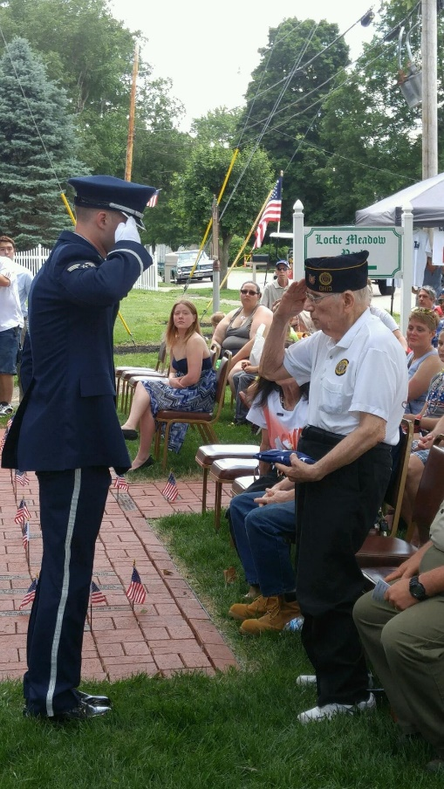

*Memorial Day Honoree Donald Hafey*

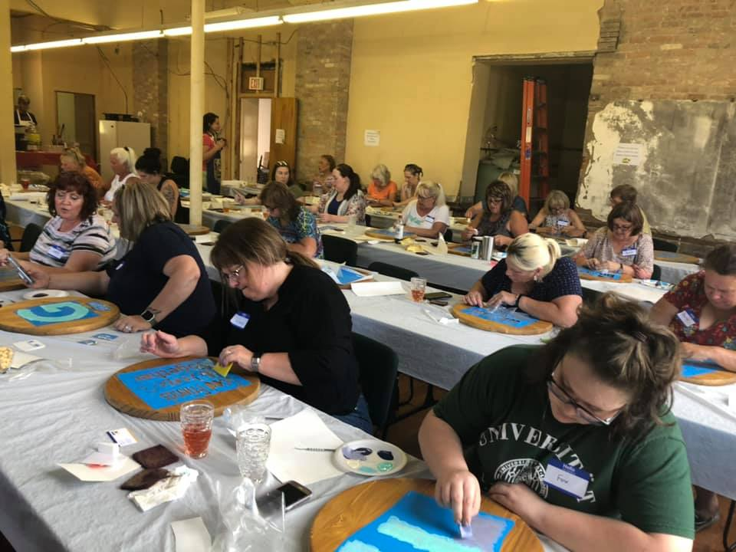

*Rediscover Lockbourne Fundraiser*

# Lockbourne School District

Children who live in Lockbourne attend Hamilton Local Schools, recognized as one of the best districts in the nation. *(U.S. News and World Report)*

**[](https://www.google.com/url?sa=i&rct=j&q=&esrc=s&source=images&cd=&cad=rja&uact=8&ved=0ahUKEwjGobOG0KrYAhXE7IMKHfEDALgQjRwIBw&url=https://www.linkedin.com/company/hamilton-local-school-district&psig=AOvVaw1dy9ONgpKU1UHvx8MyMJu7&ust=1514478912052008)**

**District Administrative Offices**

Mark Tyler, Superintendent

775 Rathmell Road, Columbus, Ohio 43207

(614) 491-8044

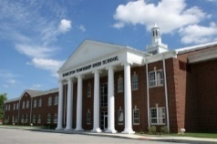**High School**

[Robert Lanthorn](mailto:rlanthorn@hlsd.org), Principal

1105 Rathmell Road, Columbus, Ohio 43207

(614) 491-8044

**Middle School**

[Jeff Endres](mailto:jendres@gapps.hls.k12.oh.us), Principal

755 Rathmell Road, Columbus, Ohio 43207

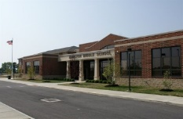(614) 491-8044

**Intermediate School**

[Kelly Buxton](mailto:kbuxton@hamilton-local.k12.oh.us), Principal

765 Rathmell Road, Columbus, Ohio 43207

(614) 491-8044

**Elementary School**

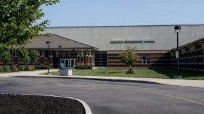[Josh H. Conley, Ed. D.](mailto:jconley@hamilton-local.k12.oh.us), Principal

745 Rathmell Road, Columbus, Ohio 43207

(614) 491-8044

**Preschool**

[Jan Strahm](mailto:jstrahm@hamilton-local.k12.oh.us), Coordinator

775 Rathmell Road, Columbus, Ohio 43207

(614) 491-8044

[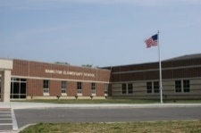](http://www.google.com/url?sa=i&rct=j&q=&esrc=s&source=images&cd=&cad=rja&uact=8&ved=0ahUKEwitn9Twz6rYAhWIw4MKHauQBqkQjRwIBw&url=http://www.hamilton-local.k12.oh.us/elementaryschool_home.aspx&psig=AOvVaw1dy9ONgpKU1UHvx8MyMJu7&ust=1514478912052008)

**School Website**: [www.hamilton-local.k12.oh.us/](http://www.hamilton-local.k12.oh.us/)

**School Facebook**: <https://www.facebook.com/HamiltonRangers/>

**School Twitter**: <https://twitter.com/HamiltonLocalSD>

# Code Enforcement

The Village of Lockbourne Property Maintenance Code and Zoning Code establishes a minimum standard that structures and exterior property must meet. Property maintenance in the Village of Lockbourne is an integral part in maintaining a well-kept community. Maintaining one’s property adds value and character to the community where we live.

The International Property Maintenance Code and the Zoning Code are documents that are used to maintain and enforce the character of properties within the Village. If a property owner is in violation of the Property Maintenance Code, the process is as follows:

* Violation Observed, a warning is received by property owner.

Property owner has (7) seven days to correct violation.

* If violation is not corrected, a citation is sent by certified mail.

Property owner has (7) seven days to correct violation.

* If citation is not correct, there are two potential avenues:

a) Village will resolve the violation, assessment of work will be placed on property, or;

b) Violation will be turned over to Village Solicitor for possible Environmental Court proceedings.

**Address Posting**

All residents must display on their residence house numbers on the front not less than 4 inches or more than 10 inches so that they are visible from the street. *(Ord. 9-90)*

**Exterior Property**

Such violations include, but are not limited to:

* Grass over 7” is prohibited
* Overgrown tree limbs and bushes over the streets, alleys, and sidewalks rights of way
* Broken or dilapidated fences, walls, or other structures
* Deteriorated structures, roofs, windows, etc.
* Broken, uneven, or improperly maintained walks or driveways
* Motor vehicles, trailers, boats, and/or other motorized vehicles parked in grass
* Storage of building materials or materials such as earth, sand, or dirt not intended for current use on the property
* Improperly disposed of materials, junk and clutter, unkempt garbage, trash, litter, and yard waste including tires
* Unregistered, inoperative or disassembled vehicles on street or your property

**Weeds**

Noxious weeds are prohibited, such as (but not limited to) thistle, ragweed, poison ivy, poison oak, poison sumac, and burdock.

For any questions pertaining to code enforcement, please contact the Mayor’s office at (614) 491-3161.

**Zoning and Fence Permits**

If you are making upgrades or changes to your home and property, you must apply for a residential zoning permit. Only one (1) accessory structure is permitted on each property in addition to a garage. Zoning permits are required for additions, decks, porches, enclosures, garages, or any new structures.

Process for Residential Zoning Permit

1. Obtain permit application (Applications are available in the Village office, there is a $20.00 application fee)
2. Complete all phases of application (must be submitted within 48 hours of Planning Commission Meeting)
3. Present to Planning Commission Meeting (1st Thursday of month @ 6:30 pm at Lockbourne Municipal Building, 85 Commerce Street, Lockbourne)
4. If approved, obtain building permit from Franklin County Building Department (150 South Front Street, FSL Suite 10, Columbus, Ohio 43215, Tel: 614-525-3095 Fax: 614-525-7155)

<https://development.franklincountyohio.gov/building-permits>

**You must apply for a Residential Zoning Permit and obtain approval by the Planning Commission before applying for a Building Permit with Franklin County.**

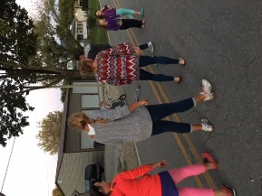Fence Permits must be obtained for any installation of fences, including invisible fences. Fences are NOT permitted in the front yard. Fences may be erected in side or rear yards, up to a maximum height of six (6) feet. Applications for Fence Permits are available in the Village office, there is $20.00 application fee.

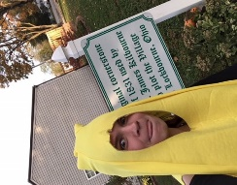

*Boo at the Boot*

*Community Block Party*

# Income Tax

The Village of Lockbourne is a member of the Regional Income Tax Agency (RITA). RITA administers and collects the Village’s income tax.

**Income Tax**

The Village of Lockbourne Income tax is 1.0% of earned income. For residents working in other municipalities, the Village does not offer a credit towards local income tax paid elsewhere.

**Income Tax Forms**

To file and pay your annual Lockbourne income tax, go to the RITA website at [www.ritaohio.com](http://www.ritaohio.com).

**RITA Contact Information**

For questions pertaining to local income tax, please contact RITA using the contact information below.

RITA Phone Number: (800) 860-7482

RITA Website: www.ritaohio.com



*Lockbourne at Sunset*

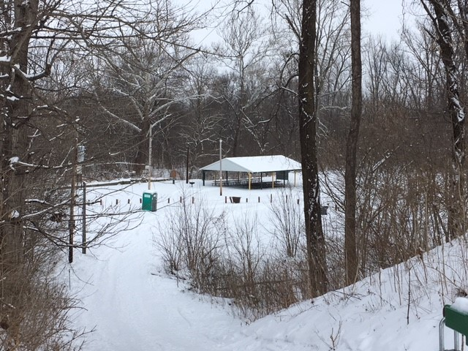

*Locke Meadow Park*

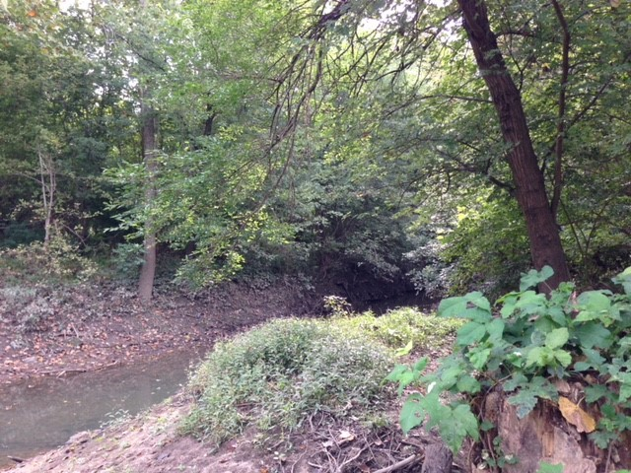

*Magnolia Trail*

# Parks and Recreation

**Locke Meadow Park**

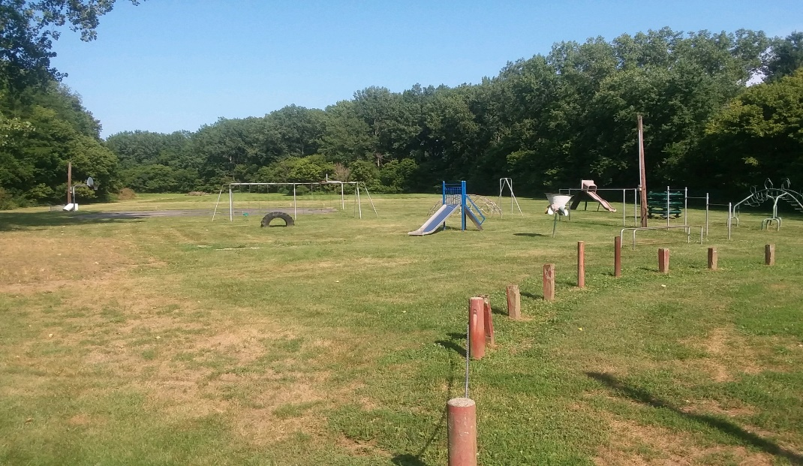

Our largest park to date, Locke Meadow Park has spacious grounds, a basketball court, playground equipment and a shelter house. Locke Meadow Park is a great place for community events and family gatherings.

You may reserve the shelter house in the park for a special event. Fees are $25.00, along with a $25.00 refundable deposit. Contact the municipal building to complete a *Shelter House Rental Application*.

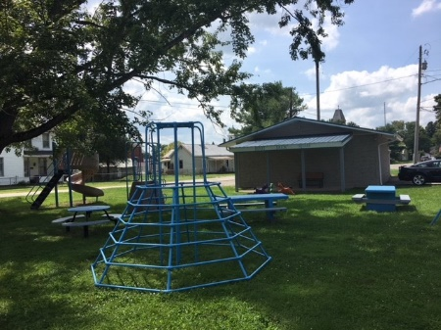

**Boot Jack Square**

Located at the town center, Boot Jack Square is where we have the majority of our community activities. Playground equipment is there for children to enjoy.

**Magnolia Trail**

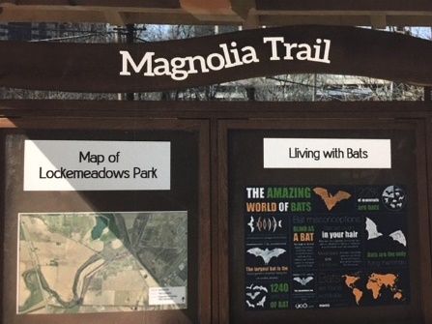

A walking trail around Locke Meadow Park and along the canal path, extending out to cover over a mile in trails. Three discontinuous trails will soon be connected.

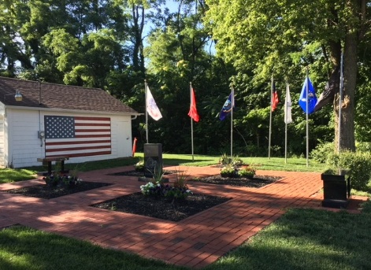

**Veterans Park**

The Veterans Park is where we host our annual Memorial Day Parade and Celebration. Residents are encouraged to attend, as well as purchase a commemorative brick or flag to honor someone in their life. There will be a new Veterans Park located in the center of town soon.

# 2021 Community Calendar

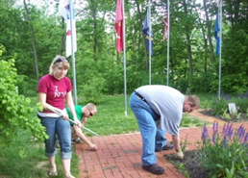

**Community Clean Up**

**Easter Egg Hunt**

**Boo at the Boot**

**Christmas Hop**

Dec 5 @ 6:00p

**Community Yard Sale**

**Community Block Party**

**Scavenger Hunt**

**Memorial Day Parade**

**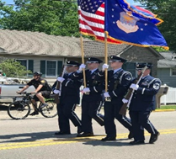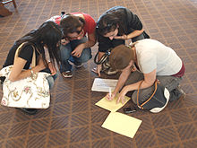****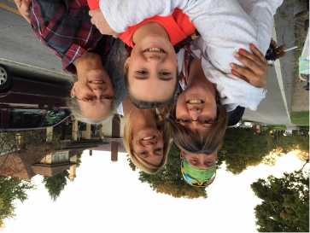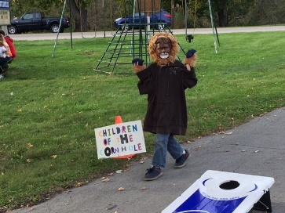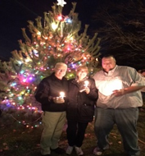**

# 2021 Special Events

|  |  |  |
| --- | --- | --- |
| **Easter Egg Hunt** |  | **Community Block Party** |
| Children are encouraged to join us in the park to hunt some eggs! Make sure you bring a basket or container to use while gathering eggs.  Location: Locke Meadow Park  Date: April 3rd  Time: 1:30 pm  Ages: 0 – 12 |  | Come out to meet your neighbors and make new friends for a night of fun for the whole family. Bring a dish or food to share.  Location: Old Schoolhouse  85 Commerce Street  Date: Sept 25  Time: 2-6 pm  Ages: All |
|  |  |  |
| **Community Clean-Up Day** |  | **Community Yard Sale** |
| The village has scheduled a spring  clean-up for May 17-19. Dumpsters will be placed around town, so all residents can discard bulk items as well.  Location: Landis, Mechanics  and Commerce Streets  Date: May 17-19 |  | Clean out your house and garage and turn your unwanted “junk” into cash by participating in the Community Yard Sale!    Location: Village-wide  Date: June 4&5  Time: 8:00 am – 3:00 pm |
|  |  |  |
| **Memorial Day Parade** |  | **Boo at the Boot** |
| Honor the men and women who died while serving in the U.S. military. This year’s celebration will focus on the Hometown Heroes from Hamilton Township. If you are interested in participating in the parade,  please call (614) 491-3161. Local veterans are asked to join us.  Location: Veterans Park  154 Commerce Street  Date: May 31st  Time: 12:00 noon |  | Another community party, Halloween Themed! Games, snacks, and prizes for best costume! Fun for all ages.  Location: Boot Jack Square  85 Commerce Street  Date: Coming 2022  Time: 4:00 pm – 6:00 pm  Ages: All |
|  |  |  |
| **Scavenger Hunt** |  | **Christmas Hop** |
| Join us for a family scavenger hunt benefitting the Memorial Day Parade. Start at Boot Jack Square to receive your clues leading you from one location to another. Cost is $10.00 per family.  Location: Boot Jack Square  85 Commerce Street  Date: Coming 2022  Time: 7:00 pm |  | **Christmas Tree Lighting Only.** Please wear masks and practice social distancing. Outside event.  Location: Lockbourne Historical Hall  206 Vause Street  Date: Saturday, December 5  Time: 6:00 pm |

# Lockbourne’s Organizations

**Memorial Day Parade Committee**

Each Memorial Day, Lockbourne honors our veterans with a parade down Commerce Street, followed by a ceremony at Veterans Park. The Memorial Day Parade Committee is a non-profit organization that plans and executes the festivities on Memorial Day.

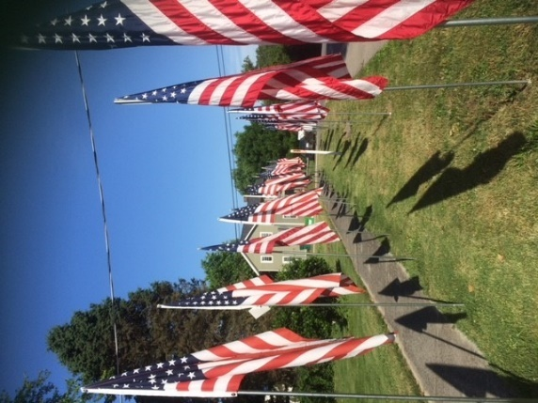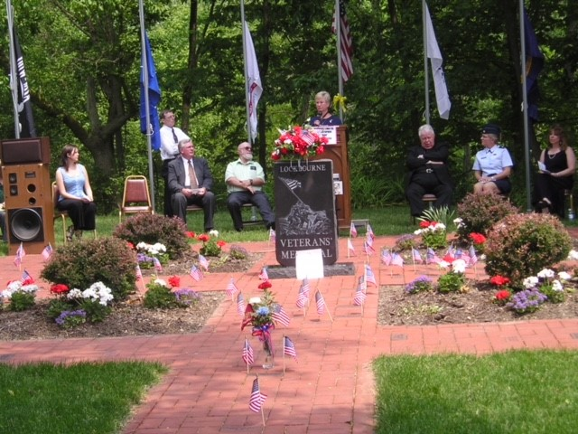

*Veterans Park*

*Field of Flags*

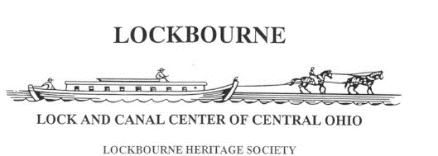

**Lockbourne Heritage Society**

The Lockbourne Heritage Society is a non-profit organization that researches, preserves and promotes the history of Lockbourne, Ohio. Throughout the year, the Heritage Society will raise funds to give back to the community. Some projects funded by the Heritage Society include Veterans Park, the Memorial Day Parade, the annual Easter Egg Hunt and holiday bags for the elderly and shut-ins. Learn more of Lockbourne’s history at <http://www.lockbourneohio.us/about/historical-timeline>

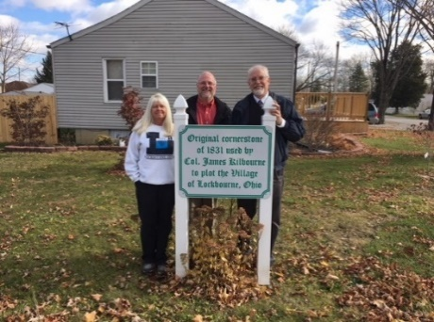

*Lockbourne Cornerstone*

**Rediscover Lockbourne**

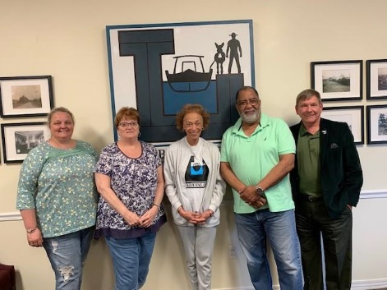Rediscover Lockbourne, a 501(c)3 organization, was established to support the village. The board is composed of current and former Lockbournians as well as friends of Lockbourne. The primary goal of the organization will be to raise money for the Old School House renovations and fund community events.

***To learn how you can get involved with these committees and organizations, contact the Village office at (614) 491-3161.***

*Rediscover Lockbourne*

# History of Lockbourne

Lockbourne, Ohio - A true American small town! We are proud to be a small quaint community with the population of about 280 people, 100 households, five (5) churches and no stoplights.

We are home to three (3) parks and three (3) historical cemeteries. Lockbourne is rich in Ohio history. Considered the lock and canal center of Central Ohio, Lockbourne gets it unique name from the locks that surround the Village and Col. James Kilbourne, who was instrumental in its development.

With its location so close to Columbus, Lockbourne once served as a junction point between the Columbus Feeder Canal and the Ohio & Erie Canal, and was central to commerce in 19th century Ohio. Lockbourne maintained a staircase of 8 locks (numbered 23-30) and two canal basins. You can still view Lock 30 in Lockbourne's Locke Meadow Park today. The last remnants of the Columbus Feeder can also be found on both sides of the Big Walnut Creek.

When an Air Force base was built just east of Lockbourne, it served as a training facility for military pilots preparing for service in WWII. In 1945, it was renamed Lockbourne Army Air Base, after the Village. In 1946, the Tuskegee Airmens’ 447th Composite Group moved to Lockbourne AAB, and became the only all-black Air Force Base that ever existed. Colonel Benjamin O. Davis, Jr., the first Afro-American to obtain the rank of General in the US Air Force, commanded the base.

During World War II, the Base trained Army Air Force glider pilots, including the Women Airforce Service Pilots (WASPs). In 1948, it was renamed Lockbourne Air Force Base and in 1974 the base was once again renamed after World War I flying ace, and Columbus native, Eddie Rickenbacker.

The Locks and Canals have been placed on the National Registry of Historic Places. As development is occurring all around us, Lockbourne is working to responsibly develop its own growth with a vision and plan for its future.

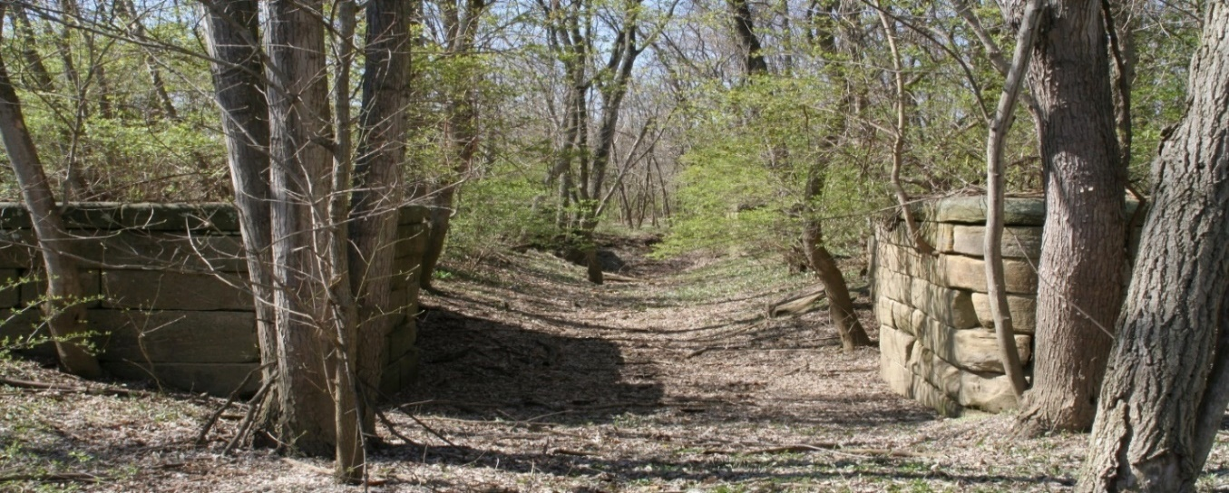

*Columbus Feeder Guard Lock*

# Lockbourne Businesses and Churches

# 

## Lockbourne Businesses

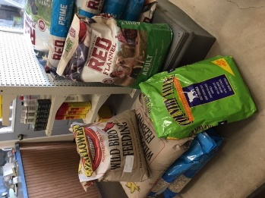**Lockbourne AG Center**

10 Commerce Street

(614) 491-0635

Hours: Monday – Friday @ 8:00 am – 5:00 pm

Facebook: www.facebook.com/Lockbourne AG Center

Goods & Services: Small animal feed & grain; bulk liquid feed for livestock & horses

**Post Office**

1 Mechanics Street

(614) 497-9482

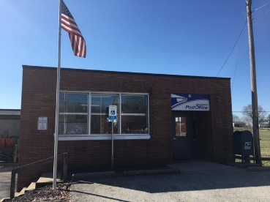Hours: Monday – Friday @ 7:00 am – 11:30 am and 1:00 - 3:45 pm; Saturday @ 7:00 am – 10:30 am

Goods & Services: Postal services

*If your property is not on the mail route, (Commerce & Williams Streets), you will be assigned a P.O. Box at the Post Office at no charge. Please contact the Post Office for more information.*

**Angell Properties Airbnb**

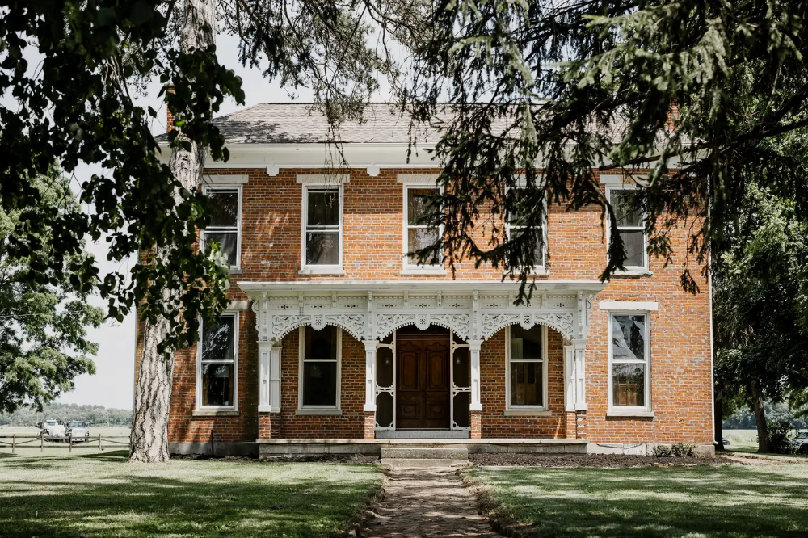

South High Street Lockbourne

Contact Sharon at [www.airbnb.com](http://www.airbnb.com)

Travel Accommodations & Rental services:

Angell Farms estate was built in the early 1840s and rests at the corner of a 600 acre working farm. The estate features historic barns and ruins for a unique and relaxing experience. This retreat is fully dedicated to guest travel.

For more information please contact Sharon on the Airbnb website during normal business hours.

## Lockbourne Churches

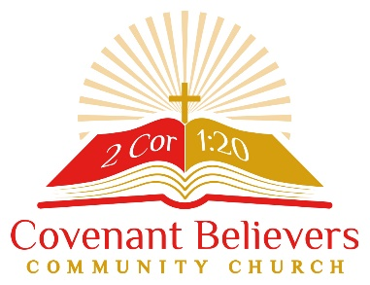

**Covenant Believers Community Church**

99 Commerce Street

(614) 500-7651

Pastor Keia Holt

Services: Sunday 11:00 am, Wednesday 6:30 pm on Facebook Live

Facebook: [www.facebook.com/CovenantBelieversCC](http://www.facebook.com/CovenantBelieversCC)

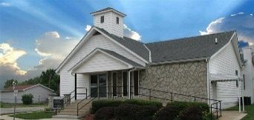**Church of Christ in Christian Union**

165 Mechanics Street

(614) 491-3803

Pastor Ron Goodling

Services: Sunday 10:30 am, Sunday 6:00pm, Wednesday 7:00pm

Facebook: <https://www.facebook.com/groups/1024592280901321/>

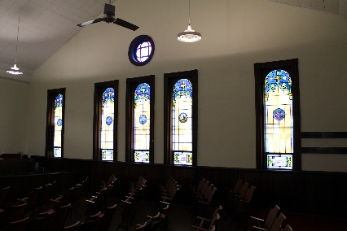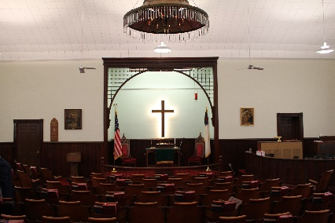**United Methodist Church**

1260 Vause Street

(614) 486-5850

Pastor Vijay Buck

Services: Sunday @ 9:30 am

# Local Attractions

## Parks & Recreation

|  |  |
| --- | --- |
| **Slate Run Historical Farm & Park**  1375 State Route 674  Canal Winchester, 43110  (614) 833-1880  11 miles from Lockbourne | **Scioto Grove**  5172 Jackson Pike  Grove City, 43123  (614) 949-1078  6 miles from Lockbourne |
| **Groveport Recreation Center**  7370 Groveport Road  Groveport, 43125  (614) 836-1000  7 miles from Lockbourne | **Three Creeks Metro Park**  3860 Bixby Rd  Groveport, 43125  [(614) 208-2874](https://www.google.com/search?source=hp&ei=qvKdWurnJIra5gLS5b0w&q=three+creeks+metro+park&oq=three+creeks+m&gs_l=psy-ab.1.0.0l5j0i46k1j46l2j0l4.1588.7327.0.10954.17.13.1.2.2.0.161.1473.0j11.11.0....0...1c.1.64.psy-ab..3.14.1561.0..35i39k1j0i131k1j0i20i264k1j0i13i46k1j46i13k1j0i13k1.0.A3agiPUTjTs)  7 miles from Lockbourne |

## Arts & Theater

|  |  |
| --- | --- |
| **Columbus Museum of Art**  480 East Broad Street  Columbus, 43215  (614) 221-6801  12 miles from Lockbourne | **Ohio Theater**  39 East State Street  Columbus, 43215  (614) 469-0939  11 miles from Lockbourne |
| **Palace Theater**  4190 34 West Broad Street  Columbus, 43215  (614) 469-9850  11 miles from Lockbourne | **Southern Theater**  21 East Main Street  Columbus, 43215  (614) 340-1896  10 miles from Lockbourne |

## Sports

|  |  |
| --- | --- |
| **Obetz Fortress**  1841 Williams Road  Obetz, 43207  (614) 409-4422  7 miles from Lockbourne | **Mapfre Stadium Sports**  One Black and Gold Boulevard  Columbus, 43211  (614) 447-2739  18 miles from Lockbourne |
| **Nationwide Arena**  200 West Nationwide Boulevard  Columbus, 43215  (614) 246-2000  13 miles from Lockbourne | **Huntington Park**  330 Huntington Park Lane  Columbus, 43215  (614) 462-5250  13 miles from Lockbourne |

## Restaurants

|  |  |
| --- | --- |
| **Eldorado Scioto Downs**  6000 South High Street  Lockbourne, 43137  (614) 295-4700  4 miles from Lockbourne | **Brew Brothers – Eldorado Scioto Downs**  6000 South High Street  Lockbourne, 43137  (614) 295-4700  4 miles from Lockbourne |
| **Paddock Pub**  1005 Richardson Road  Groveport, 43125  [(614) 610-9688](https://www.google.com/search?source=hp&ei=xaecWpOTAYmb_QaZ95XwCw&q=paddock+pub&oq=paddock&gs_l=psy-ab.1.0.0i20i264k1l2j0l2j0i131k1j0l5.321.1236.0.4945.8.6.0.1.1.0.267.565.0j2j1.3.0....0...1c.1.64.psy-ab..4.4.597.0..46j35i39k1j0i46k1.0.fZrOQancFm4)  6 miles from Lockbourne | **Cimi’s Bistro**  1500 Pinnacle Club Drive  Grove City, 43123  [(614) 539-0397](https://www.google.com/search?ei=yqecWrTuN-qMgge-o4-ABw&q=cimi%27s+bistro&oq=cimi&gs_l=psy-ab.1.0.0i20i264k1j0l7j0i46k1j46l2j0.99519.100214.0.104677.4.4.0.0.0.0.213.811.0j1j3.4.0....0...1c.1.64.psy-ab..0.4.803...35i39k1j0i131k1j0i67k1.0.Eaox_48sbfM)  7 miles from Lockbourne |

## Pizza

|  |  |
| --- | --- |
| **Lombardi’s**  6251 South High Street  Lockbourne, 43137  (614) 491-6500  4 miles from Lockbourne | **Cardo’s**  3606 Lockbourne Road  Columbus, 43207  (614) 409-9229  6 miles from Lockbourne |
| **Possum Holler**  1874 Lisle Road  Obetz, 43207  [(614) 497-1355](https://www.google.com/search?source=hp&ei=xaecWpOTAYmb_QaZ95XwCw&q=paddock+pub&oq=paddock&gs_l=psy-ab.1.0.0i20i264k1l2j0l2j0i131k1j0l5.321.1236.0.4945.8.6.0.1.1.0.267.565.0j2j1.3.0....0...1c.1.64.psy-ab..4.4.597.0..46j35i39k1j0i46k1.0.fZrOQancFm4)  6 miles from Lockbourne | **Little Italy**  619 Main Street  Groveport, 43125  [(614) 836-3056](https://www.google.com/search?ei=yqecWrTuN-qMgge-o4-ABw&q=cimi%27s+bistro&oq=cimi&gs_l=psy-ab.1.0.0i20i264k1j0l7j0i46k1j46l2j0.99519.100214.0.104677.4.4.0.0.0.0.213.811.0j1j3.4.0....0...1c.1.64.psy-ab..0.4.803...35i39k1j0i131k1j0i67k1.0.Eaox_48sbfM)  5 miles from Lockbourne |

## Learning

|  |  |
| --- | --- |
| **COSI (Center of Science and Industry)**  333 West Broad Street  Columbus, 43215  (614) 228-2674  14 miles from Lockbourne | **Mott’s Military Museum, Inc**  5075 South Hamilton Road  Groveport, 43125  (614) 836-1500  7 miles from Lockbourne |
| **Library – South High Branch**  3540 South High Street  Columbus, 43207  614-645-2275  6 miles from Lockbourne | **Main Library**  96 South Grant Avenue  Columbus, 43215  614-645-2275  12 miles from Lockbourne |